IPsec VPN Overview

Site Name:-Tigo_ Engrafi_TZ

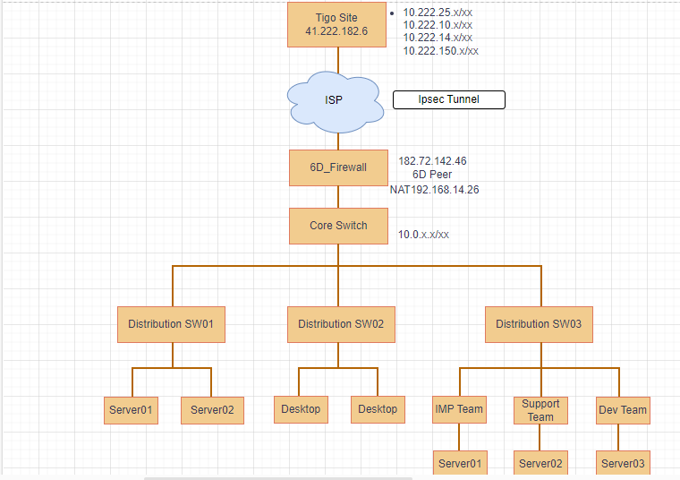

Site-to-Site Tunnel:-

Device-Sophos XG

Existing Site-to-Site VPN coniguration :-

Source Peer: - 182.72.142.46

Destination Peer: - 41.222.182.6

Phase1:-

Encryption AES256

Authentication- Sha1

DH group 2

Key life 86400

Phase2:-

Encryption AES256

Authentication Sha1

PFS none

Key life 3600

Source IP: -

192.168.14.26

Destination IPs:-

10.222.10. x

10.222.14. x

10.222.150. x